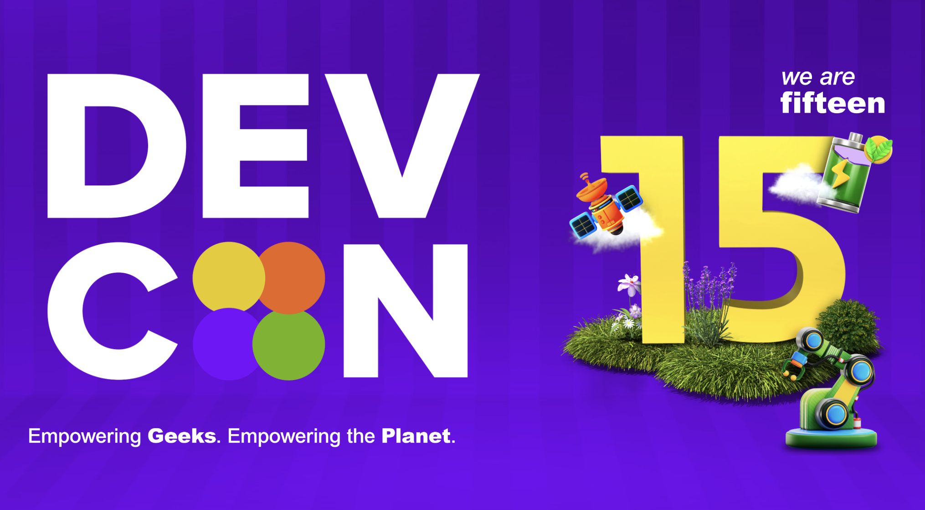

**Hi DEVCON Leaders,**

I'm excited to share the "DEVCON HQ Insights 02" report, which is packed with valuable information gathered from over 400 volunteer applications and detailed insights. This report is a powerful tool to help us refine our strategies and strengthen our community. It reinforces the effectiveness of our volunteer-driven and inclusive approach, highlighting key areas where we can grow. Think of it as a strategic roadmap to amplify our impact, ensuring we continue to empower Filipino developers and cultivate a thriving tech ecosystem. We believe this data will enable us to make smarter decisions, enhance our events, and better support our volunteers and students. We're eager to hear your comments and feedback, so please don't hesitate to share your thoughts.

**Here’s to building better communities,**

**Dom**

**DEVCON HQ**

**Key Takeaways for Action, Informed by 400+ Volunteer Applications and Insights:**

* **Leverage Social Media and Word-of-Mouth (Amplified by Volunteer Data):**
  + Capitalize on Facebook's reach, as evidenced by volunteer application sources, and encourage organic sharing to expand our community.
  + Strengthen referral programs, leveraging the strong network connections revealed in volunteer applications, to amplify word-of-mouth engagement.
* **Enhance Event Experiences (Driven by Attendee and Volunteer Feedback):**
  + Prioritize quality content and speaker selection, focusing on trending topics, as highlighted by both attendee feedback and volunteer interest.
  + Invest in interactive workshops and networking sessions, meeting the expressed desires of both attendees and potential volunteers, to create engaging and memorable events, particularly for Campus DEVCONs and Geek Up events.
* **Empower Volunteers (Based on Volunteer Skillsets and Experience):**
  + Recognize and support our volunteers, especially those with experience in organizations like GDSC and AWS User Group, as demonstrated by their prevalent experience in the applications.
  + Provide opportunities for skill development and leadership growth, aligning with the diverse skillsets and aspirations identified in the volunteer applications.
* **Focus on Student Engagement (Reflecting Student Dominance in Applications):**
  + Continue to nurture student involvement through targeted programs and events, acknowledging the significant student representation within the volunteer pool and overall community.
  + Recognize the students as the future of the organization, and give them the tools that they need to succeed.
* **Deliver Five-Star Conferences (Guided by Attendee Expectations):**
  + Prioritize quality content, networking, interactive experiences, smooth logistics, and a strong sense of community, reflecting the key elements that attendees value, as expressed in the insights.
  + Emphasize the "human connection" to create a truly exceptional experience, a sentiment echoed throughout the qualitative feedback.
* **Nationwide and Chapter Alignment (Facilitated by Data Transparency):**
  + Use this data, derived from both the report and the volunteer applications, to ensure that the nationwide goals and chapter-level activities are aligned.
  + This will allow for more effective use of resources and a more cohesive community, with shared understanding of community demographics and needs.
* Data-Driven Decisions (Enabled by Comprehensive Insights):
  + Use the data found within the report, and the added context from the volunteer applications, to make informed decisions about future events, programs, and community outreach.
  + **Utilizing the volunteer application data, will allow for better placement of volunteers, and a more effective volunteer workforce.**

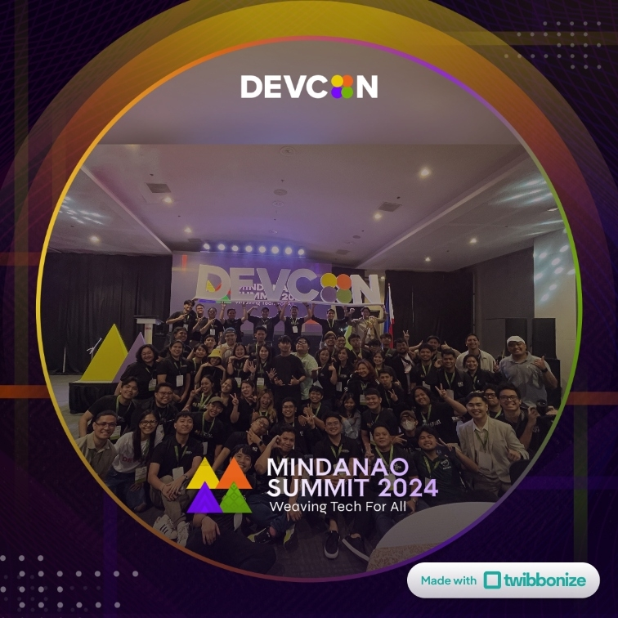

**Based on the responses, here's what makes DEVCON unique as a volunteer organization and tech community:**

Key Unique Aspects:

* Nationwide Reach and Inclusivity:
  + DEVCON has a significant presence across the Philippines, with chapters and events in various regions, not just limited to major cities.
  + It is inclusive, welcoming individuals of all skill levels, backgrounds, and ages, from students to professionals, even kids.
* Community-Driven and Collaborative:
  + DEVCON fosters a strong sense of community, emphasizing collaboration, knowledge sharing, and mutual support.
  + It creates a space where individuals can connect, learn from each other, and grow together.
* Focus on Practical Learning and Skill Development:
  + DEVCON provides hands-on learning experiences through workshops, hackathons, and other events.
  + It bridges the gap between academia and industry, offering practical skills relevant to the current tech landscape.
* Commitment to Social Impact:
  + DEVCON is not just about technology; it also focuses on using tech for social good.
  + It addresses real-world challenges and contributes to the development of the Philippine tech ecosystem.
  + It has shown to participate in projects that help with climate and environmental issues.
* Volunteer-Driven and Passionate:
  + DEVCON relies on a dedicated team of volunteers who are passionate about technology and community development.
  + The organization values its volunteers and provides opportunities for them to grow and contribute.
* Diverse Tech Focus:
  + DEVCON embraces a wide range of technologies and platforms, rather than being tied to a single company or product.
  + This allows for exploration of diverse tools and practices relevant to the industry.
* Educational Emphasis:
  + DEVCON is seen as a place of learning, and they have programs that target a wide range of educational levels.
  + The organization has programs that are for kids, students, and professionals.

**In essence, DEVCON is seen as a dynamic and supportive ecosystem that empowers Filipino developers and contributes to the growth of the tech industry in the Philippines.**

**How People Learned About DEVCON:  
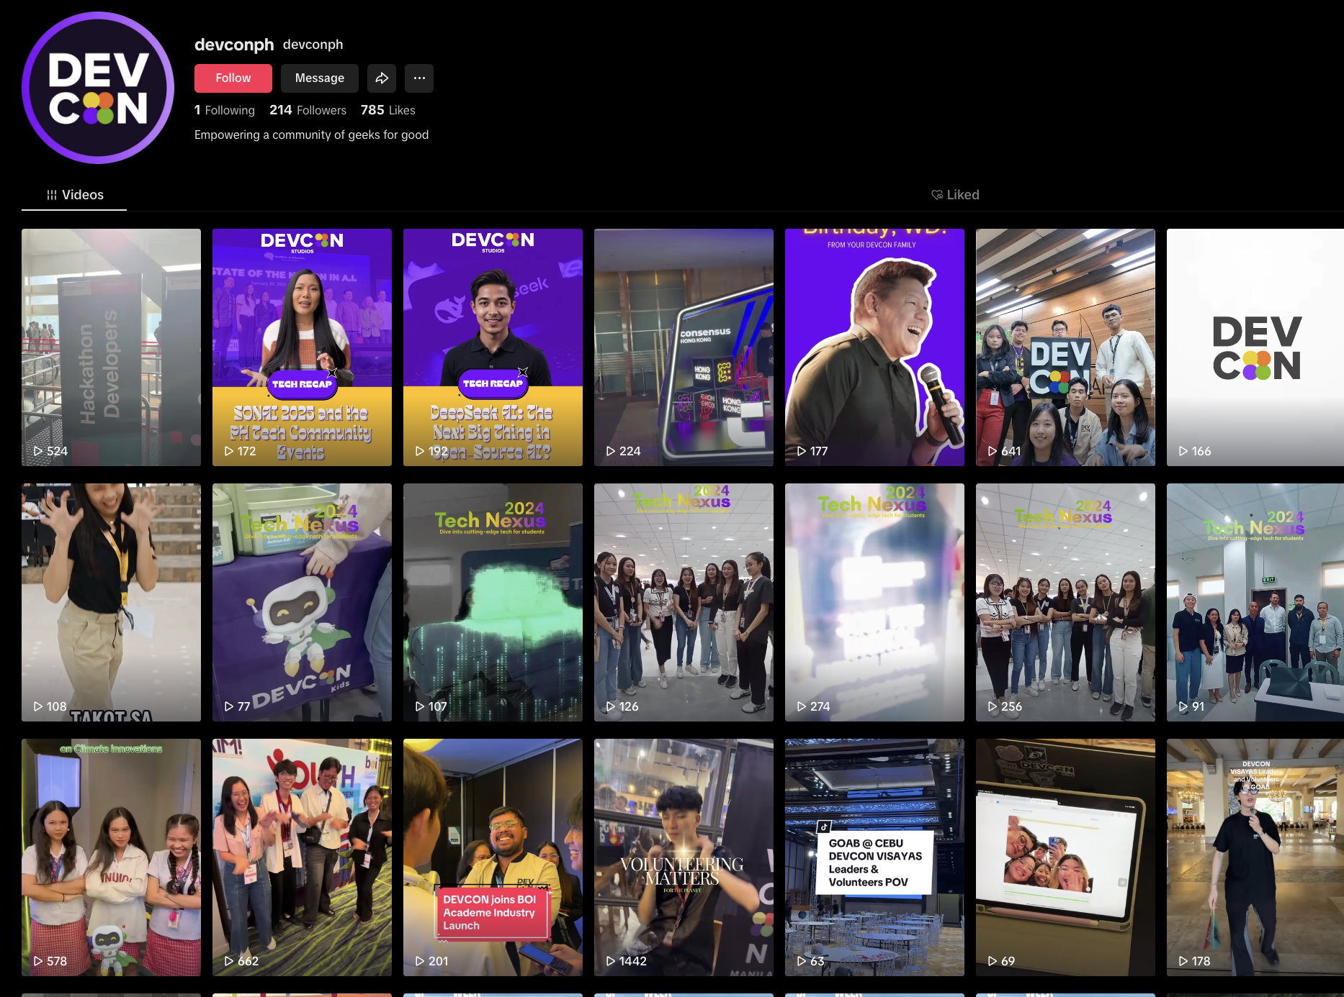**

* **Social Media Dominance:**
  + A significant portion of respondents, a large number, found out about DEVCON through Facebook posts, shared content, or general social media browsing. This indicates the strong reach of DEVCON's online presence.
  + LinkedIn also plays a role, particularly for those in professional tech circles.
* **Word of Mouth and Referrals:**
  + Many respondents learned about DEVCON through friends, colleagues, or classmates. This highlights the importance of personal networks in spreading awareness.
  + Referrals from existing DEVCON volunteers and officers were also common.
* **Campus and Community Events:**
  + Campus DEVCON events and collaborations with organizations like GDSC (Google Developer Student Clubs) were effective in reaching students.
  + Participation or observation of DEVCON booths or presence in other tech conferences and summits.
* **Direct Engagement:**
  + Some respondents attended DEVCON events as participants before becoming volunteers.
  + Some respondents learned about DEVCON through official media accounts.

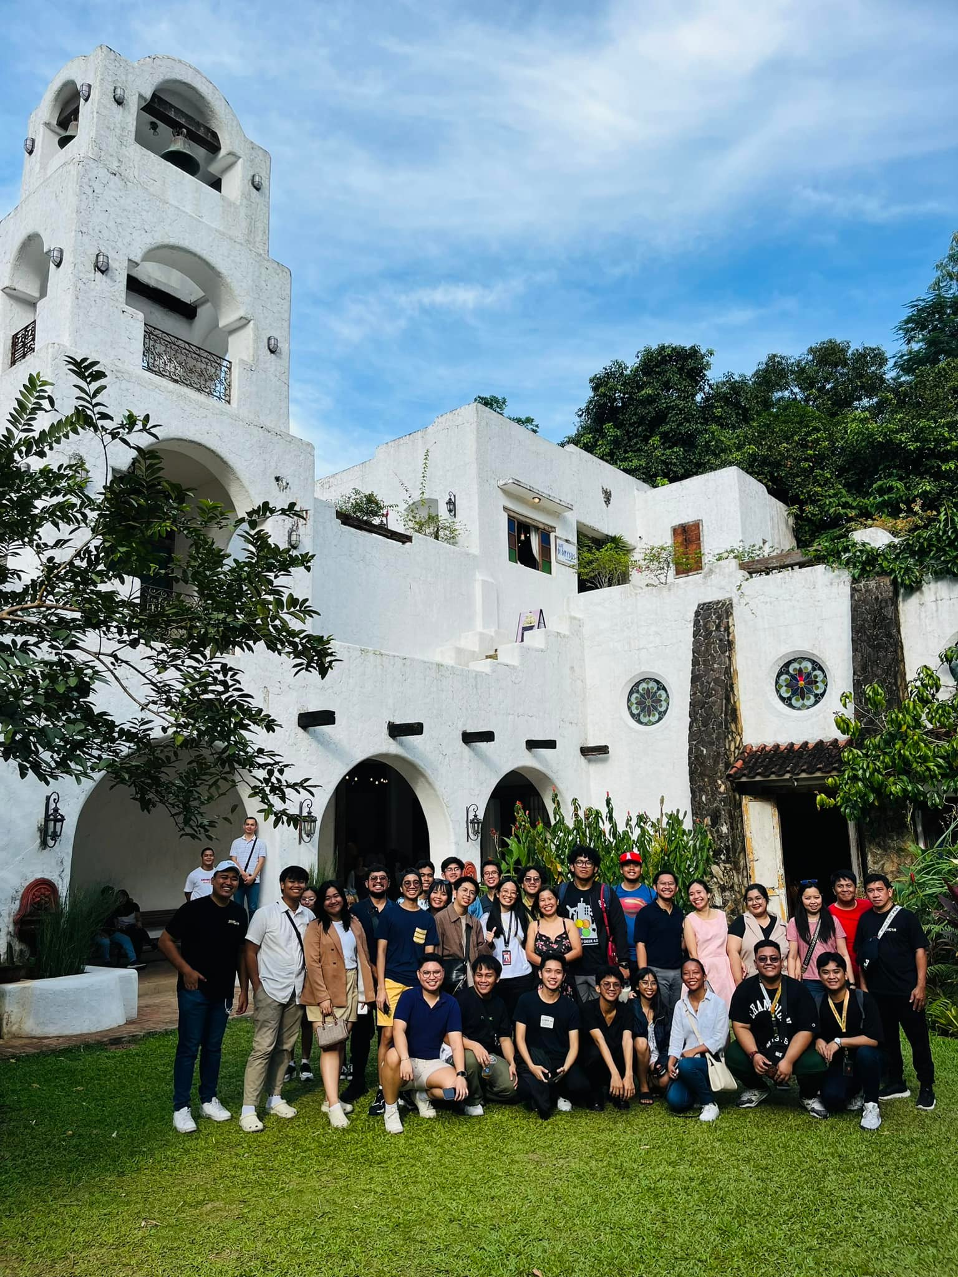

**Volunteer Experience:**

* **Varied Experience Levels:**
  + A substantial number of respondents have prior volunteer experience, ranging from school organizations and community outreach to large-scale tech events like AWS Community Day and PyCon PH.
  + Many respondents have experience in GDSC.
  + A significant number of respondents are volunteering for Devcon for the first time.
* **Tech-Related Volunteerism:**
  + Many volunteers have experience in tech-related events, indicating a passion for the field.
  + Experience in areas like ushering, registration, technical assistance, and content creation was common.
* **Diverse Backgrounds:**
  + Volunteer experience extended beyond tech, including community service, disaster relief, and other forms of civic engagement.

**Key Observations:**

* DEVCON has a strong presence across various platforms, both online and offline.
* Community engagement and word-of-mouth are crucial for attracting volunteers.
* DEVCON attracts individuals with diverse backgrounds and skill sets.
* Many of the people volunteering have also volunteered for AWS community day.

**First-Time Attendance Dominates:**

* A significant majority of respondents indicated that they have not yet attended a DEVCON event. This highlights the opportunity for DEVCON to reach new audiences.
* Many express eagerness to attend future events, showcasing a strong interest in DEVCON's offerings.

**Positive Experiences When Attended:**

* For those who have attended, the experiences are overwhelmingly positive.
* Common themes include:
  + **Learning and Inspiration:** Attendees gained valuable knowledge and were inspired by the speakers and content.
  + **Networking and Community:** The events provided opportunities to meet new people, connect with like-minded individuals, and expand professional networks.
  + **Fun and Engagement:** The events were described as enjoyable and engaging, with interactive activities and a vibrant atmosphere.
* Many people mentioned that they attended Campus Devcon events, and that those events were very beneficial.
* Many people mentioned the Geek Up events, and enjoyed them.
* Lead Learner workshops were also mentioned as a very positive experience.
* Many people attended Devcon Summit 2022, and had a great time.

**Variety of Events:**

* Respondents attended a wide range of DEVCON events, including:
  + Campus DEVCONs
  + DEVCON Summits
  + Geek Up events
  + Code camps
  + Workshops
  + Lead Learner workshops.
* This indicates the diversity of DEVCON's programming and its ability to cater to different interests.

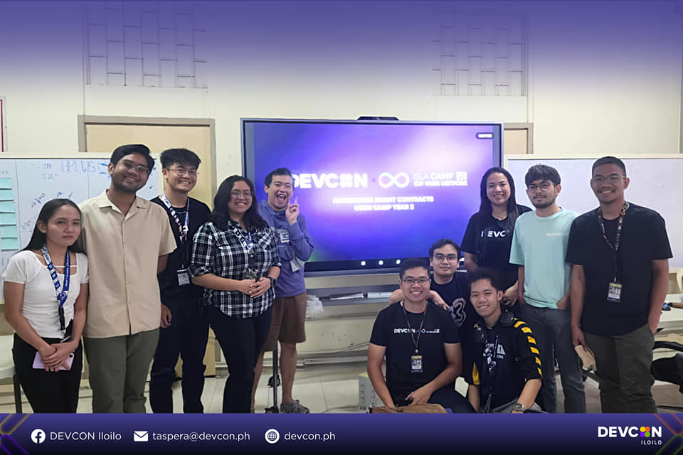**Key Observations:**

* DEVCON has a strong reputation for delivering high-quality and engaging events.
* The events are valued for their educational, networking, and community-building opportunities.
* There is a large group of people who are interested in attending DEVCON events.
* Campus Devcon events are very popular.

**Prevalence of Volunteerism:**

* A significant portion of respondents have volunteered with other organizations, indicating a strong inclination towards community involvement.
* Many respondents have experience in multiple organizations and roles.

**Types of Organizations and Roles:**

* **School and University Organizations:**
  + A very common area for volunteering, with roles ranging from officerships to event assistance.
  + Examples include student governments, academic clubs, and tech-related organizations like GDSC.
* **Tech-Related Organizations:**
  + Many respondents have volunteered with tech communities such as:
    - AWS User Group
    - Python Philippines
    - GDG (Google Developer Groups)
    - Stackleague
    - CERT PH
  + Roles include:
    - Event organization and logistics
    - Technical assistance
    - Social media and marketing
    - Creatives (graphic design, video editing)
    - Ushering and registration.
* **Community and Non-Profit Organizations:**
  + Respondents have volunteered with a wide range of community organizations, including:
    - Red Cross
    - Church groups
    - Youth organizations
    - Disaster relief efforts
    - Local government projects.
* **Diverse Roles:**
  + Volunteer roles are highly varied, including:
    - Leadership positions
    - Event coordination
    - Technical support
    - Creative work
    - Data entry
    - Logistics
    - Guest relations.

**Key Observations:**

* Many respondents have a strong commitment to volunteering and community service.
* Tech-related volunteering is prevalent, reflecting the respondents' interests and skills.
* Respondents have experience in a wide range of roles, demonstrating versatility and adaptability.
* Many respondents have volunteer experience with GDSC, and AWS.

**Student Dominance:**

* A very large portion of respondents are students, spanning various levels of education (high school to graduate studies) and fields of study (primarily Computer Science and Information Technology).
* This emphasizes DEVCON's strong appeal to and involvement with the student community.

**Diverse Affiliations:**

* Respondents are affiliated with a wide range of organizations, including:
  + **School Organizations:** Student councils, academic clubs (e.g., Computer Science societies), and tech-focused groups (e.g., GDSC, Microsoft Student Communities).
  + **Tech Communities:** AWS User Group, Google Developer Groups, Python Philippines, and various local tech meetups.
  + **Professional Organizations:** Industry-related groups and associations.
  + **Other Organizations:** Community service groups, non-profit organizations, and religious organizations.

**Variety of Roles:**

* Respondents hold a diverse set of roles, including:
  + **Students:** From freshmen to graduating seniors, studying various tech-related fields.
  + **Software Developers:** Junior to senior levels, working in various companies.
  + **UI/UX Designers:** Working in design roles.
  + **Graphic Designers:** Working on creative design.
  + **Project Managers:** Managing projects.
  + **IT Professionals:** Various roles in IT, including system administration, networking, and support.
  + **Teachers/Educators:** Teaching in various educational institutions.
  + **Business Owners/Entrepreneurs:** Running their own businesses.
  + **Freelancers:** Working independently.
  + **Community Leaders:** Leading various community groups.

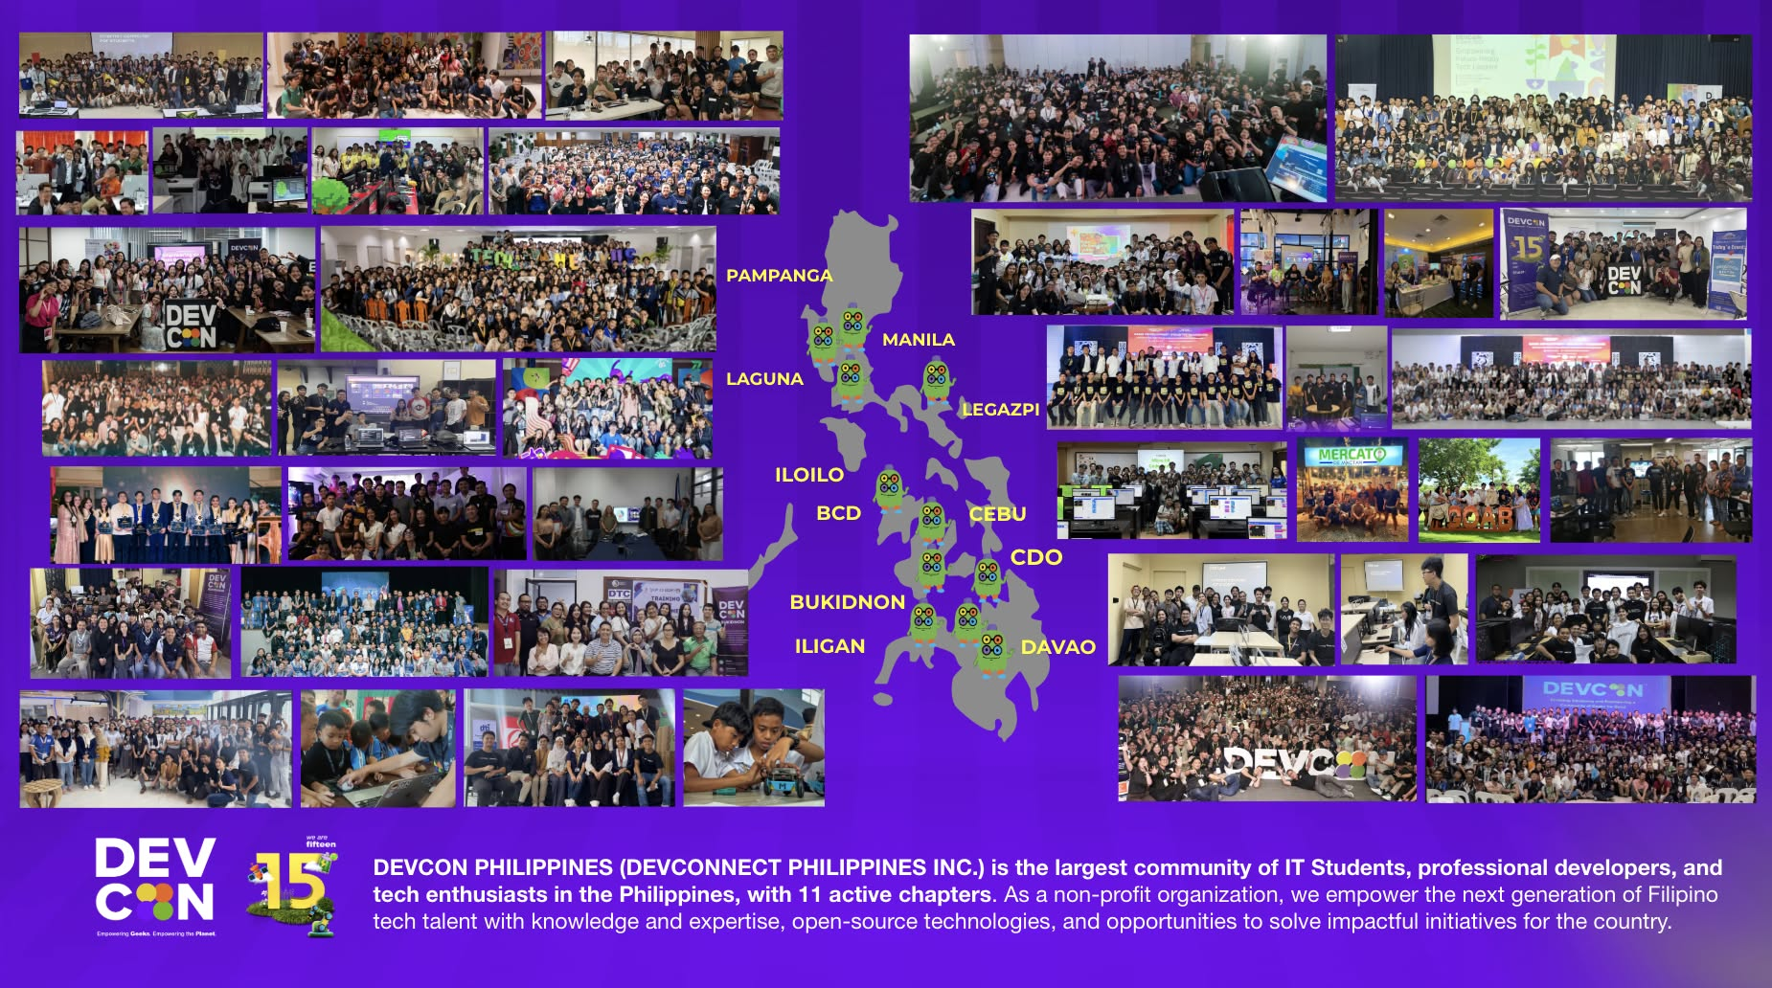**Key Observations:**

* DEVCON attracts a diverse audience, from students to professionals.
* The strong presence of students highlights DEVCON's role in fostering the next generation of tech talent.
* Respondents are actively involved in various organizations, demonstrating a commitment to community engagement and professional development.
* The large number of GDSC affiliations is very apparent.

Here's a breakdown of what respondents believe makes a five-star conference experience, beyond raffles and free tickets:

**Key Themes:**

* **Quality Content and Speakers:**
  + The most frequently mentioned factor is the quality and relevance of the content presented.
  + Attendees value insightful, engaging, and knowledgeable speakers who can provide valuable takeaways.
  + Up-to-date and trending topics are highly appreciated.
* **Networking Opportunities:**
  + Networking is considered crucial for a successful conference experience.
  + Attendees want opportunities to connect with industry professionals, peers, and potential collaborators.
  + Structured and informal networking sessions are valued.
* **Interactive and Engaging Experience:**
  + Attendees appreciate interactive workshops, panel discussions, and hands-on demonstrations.
  + Icebreakers, games, and activities that encourage participation are also valued.
  + An engaging and lively atmosphere is essential.
* **Smooth Logistics and Organization:**
  + A well-organized event with seamless logistics is crucial for a positive experience.
  + This includes smooth registration, clear program flow, and minimal technical difficulties.
  + A comfortable and accessible venue is also important.
* **Community and Connection:**
  + Attendees value a sense of community and belonging.
  + Creating an inclusive and welcoming environment is essential.
  + Opportunities to connect with like-minded individuals are highly valued.
* **Food and Amenities:**
  + While not the primary focus, good food and refreshments are appreciated.
  + A comfortable venue and good amenities contribute to a positive experience.
* **Learning and Growth:**
  + The chance to gain new knowledge and skills is a primary motivator for attending conferences.
  + Attendees want to leave feeling inspired and motivated.
* **The overall experience:**
  + Many people mentioned that the overall feeling and vibe of the conference is what makes it a 5 star experience.

**Specific Suggestions:**

* Interactive workshops and hands-on demonstrations.
* Dedicated networking sessions and opportunities for one-on-one interactions.
* High-quality speakers who are experts in their fields.
* Well-organized and smooth event flow.
* Comfortable and accessible venue.
* Engaging activities and games.
* Opportunities for career development and mentorship.
* Provide memorable experiences and meaningful connections.

**Key Observations:**

* Attendees prioritize learning, networking, and engagement.
* A well-rounded conference experience includes both educational and social aspects.
* Attention to detail and a focus on attendee experience are crucial for success.
* The human connection is a major factor in a 5 star experience.

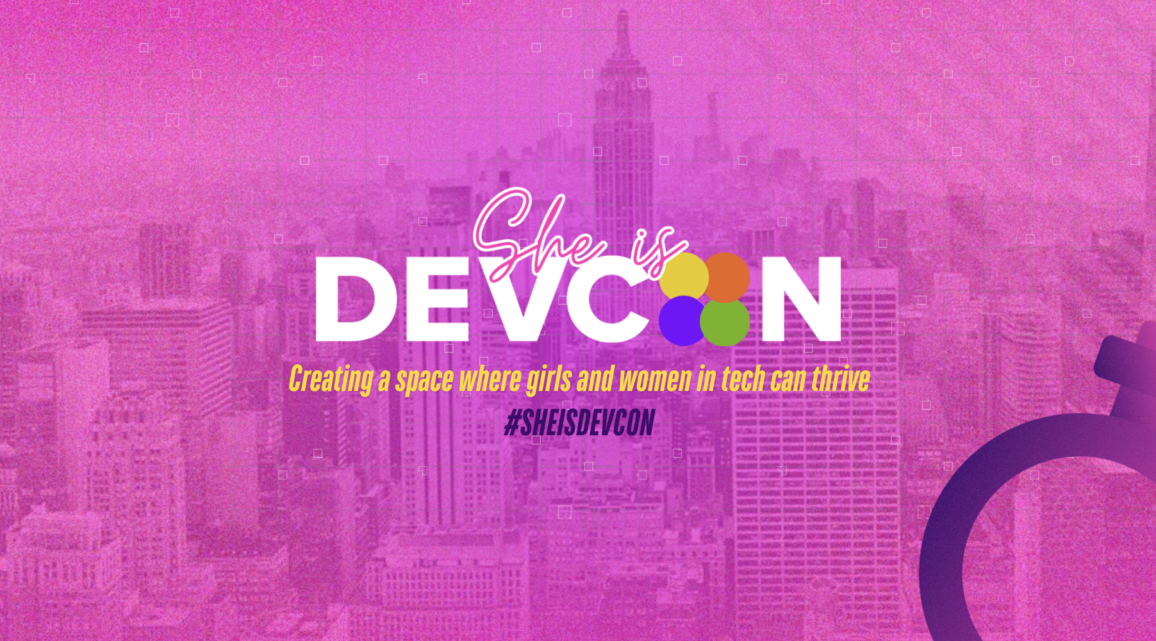

**Top 10 Action Points for Local DEVCON Chapters:**

1. **Amplify Social Media & Referral Programs:**
   * Actively utilize Facebook and LinkedIn for event promotion and community engagement.
   * Create a structured volunteer referral program to leverage existing networks.
   * Encourage organic sharing of DEVCON content by volunteers and attendees.
2. **Enhance Event Content & Interactivity:**
   * Prioritize trending tech topics and expert speakers based on volunteer and attendee feedback.
   * Implement interactive workshops and networking sessions in all events, especially Campus DEVCONs and Geek Up events.
   * Focus on delivering valuable content that can be put to practical use.
3. **Empower Volunteer Skill Development & Leadership:**
   * Recognize and leverage the experience of volunteers from organizations like GDSC and AWS User Group.
   * Offer skill development workshops and leadership training opportunities for volunteers.
   * Match volunteers to roles that utilize their skills and that they are interested in.
4. **Focus on Student Engagement & Growth:**
   * Continue to prioritize Campus DEVCONs and student-focused programs.
   * Create mentorship programs connecting students with experienced professionals.
   * Provide students with the tools and resources they need to succeed in the tech industry.
5. **Deliver Five-Star Conference Experiences:**
   * Prioritize quality content, networking, interactive experiences, and smooth logistics.
   * Cultivate a strong sense of community and "human connection" at all events.
   * Gather and implement feedback from attendees to continually improve event quality.
6. **Nationwide & Chapter Alignment:**
   * Utilize data from volunteer applications and event feedback to align chapter activities with nationwide goals.
   * Ensure transparency and communication between local chapters and national leadership.
   * Share best practices between chapters.
7. **Data-Driven Decision Making:**
   * Use volunteer data to optimize volunteer placement and utilization.
   * Analyze event feedback to identify areas for improvement and inform future programming.
   * Consistently track and analyze data to measure the impact of chapter activities.
8. **Strengthen Community Partnerships:**
   * Continue collaboration with organizations like GDSC, AWS User Group, and Python Philippines.
   * Explore partnerships with local businesses, educational institutions, and community organizations.
   * Leverage these partnerships to expand reach and resources.
9. **Promote Inclusivity and Diversity:**
   * Ensure all events and programs are welcoming to individuals of all skill levels, backgrounds, and ages.
   * Actively seek out and engage underrepresented groups in the tech community.
   * Highlight diverse speakers and role models.
10. **Focus on Practical Learning and Skill Development:**
    * Continue to host workshops and events that provide hands on experience.
    * Create events that bridge the gap between academic learning and industry standards.
    * Highlight real world applications of technology.